Question 1:
Given the following graph, show the execution of the Floyd-Warshall Algorithm. And write down the shortest path between each pair of two vertices.
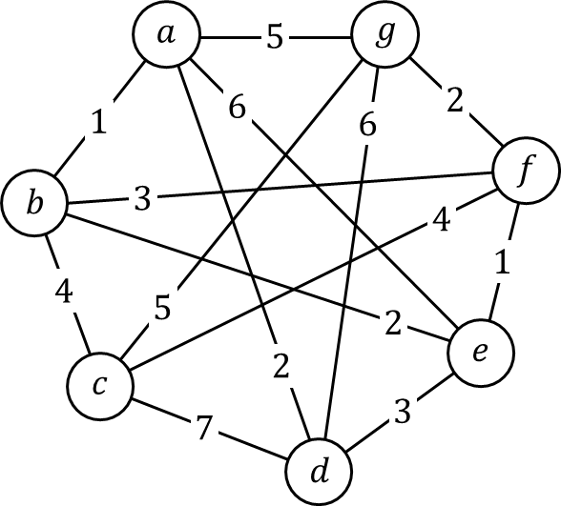

Question 2:
Given the string “ababcdabefbcdccbaeeeffadc”, use the Huffman Coding algorithm to design a prefix-free codes of the minimum encoding length.

